**Narrogin Senior High School**

**Year 11 Mathematics Methods**

**Investigation 2**

**Unit 2**

**Topic 2.1: Exponential functions**

**Course-related information**

The concepts and skills developed in this investigation relate to the following dot points within the WA Mathematics Methods syllabus:

1.1.24 use function notation; determine domain and range; recognise independent and dependent variables

2.1.1 review indices (including fractional and negative indices) and the index laws

2.1.4 establish and use the algebraic properties of exponential functions

2.1.5 recognise the qualitative features of the graph of $y=a^{x}$ $(a>0)$, including asymptotes, and of its translations ( $y=a^{x}+b$ and $y=a^{x-c}$)

**Background information**

Students should have reviewed their knowledge of indices and the index laws before sitting this assessment. They should also be familiar with, and be able to use function notation. In the investigation students are provided with the opportunity to connect their existing knowledge of the index laws with the graphs of exponential functions and the transformations of such functions.

**Task conditions**

This task consists of an in-class investigation for which students might need 40 – 55 minutes to complete. Students need to be familiar with tabulation and graphing using technology and it is expected that access to such technology will be available during the investigation.

**Exponential functions**

**In-class investigation (52 marks)**

This investigation focuses on exponential functions which have the general formula

 and where *a* >0

**Question 1 (21 marks)**

(a) Complete the tables provided for each of the given functions, rounding your answers to one decimal place. (5)

(i)

|  |  |  |  |  |  |  |
| --- | --- | --- | --- | --- | --- | --- |
| *x* | -2 | -1 | 0 | 1 | 2 | 3 |
| *f(x)=2x* |  |  |  |  |  |  |

(ii)

|  |  |  |  |  |  |  |
| --- | --- | --- | --- | --- | --- | --- |
| *x* | -2 | -1 | 0 | 1 | 2 | 3 |
| *f(x)=3x* |  |  |  |  |  |  |

(iii)

|  |  |  |  |  |  |  |
| --- | --- | --- | --- | --- | --- | --- |
| *x* | -2 | -1 | 0 | 1 | 2 | 3 |
| *f(x)=4x* |  |  |  |  |  |  |

(b) Sketch the three functions on the grid provided. (5)

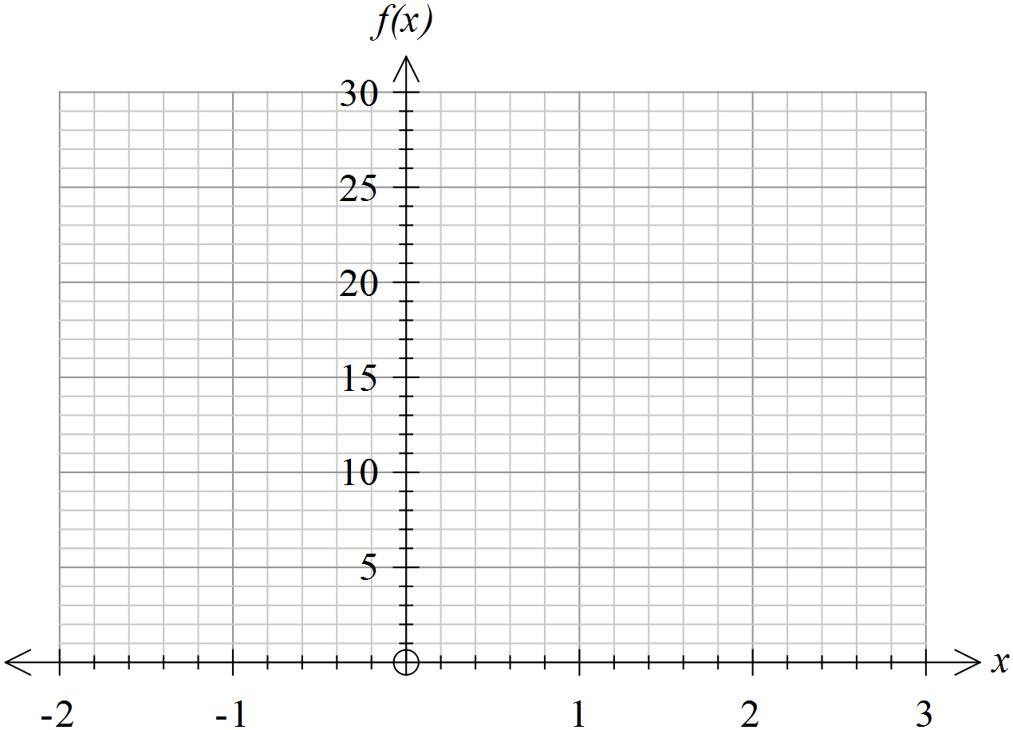

**Activity 1**

(c) State the domain for the function *f(x).* With reference to the domain, describe and justify the values *f(x)* can/cannot take. (2)

(d) State the *y*-intercept for each of the three functions. (2)

(e) State the general rule relating the *x* value at the *y*-intercept to the value of *f(x).*

(1)

(f) Considering both positive and negative values of *x*, describe the changes to the graph of  as *a* increases (*a* >1). (2)

(g) Given *f(x)=2x* and *g(x) = 2x+1*

(i) state the value of *f(3)*

(ii) state the value of *g(3)*

(iii) describe the value of *g(x)* in terms of the value of *f(x)* (3)

(h) Given *h(x)=mx* and *k(x) = mx+1* describe *k(x)* in terms of *h(x)*without any reference to *m.* (1)

**Question 2 (11 marks)**

(a) On the grid provided, sketch and label each of the following functions. (5)

*f(x) = 2x*

*g(x) = 2x+1*

*h(x) = 2x+2*

*j(x) = 2x+3*



(b) State the y-intercepts for each of these functions. (2)

(i) *f(x) = 2x*

(ii)*g(x) = 2x+1*

(iii) *h(x) = 2x+2*

(iv) *j(x) = 2x+3*

(c) The graph of  may be considered as a translation or a dilation of the graph of . Describe the graph of as (4)

1. a translation of the graph of 
2. a dilation of the graph of 

(c) The graph of  is a transformation of the graph of. (4)

(i) Is the transformation a dilation or a translation? Justify your choice.

(ii) When *c* >0, how is the graph of transformed as *c* increases?

(iii) When *c* <0, how is the graph of transformed as *c* decreases?

**Question 3 (10 marks)**

(a) For the functions below enter the values and express any numbers which are not whole numbers, as fractions. (4)

(i)

|  |  |  |  |  |  |  |
| --- | --- | --- | --- | --- | --- | --- |
| *x* | -2 | -1 | 0 | 1 | 2 | 3 |
| *f(x)=5 x* |  |  |  |  |  |  |

(ii)

|  |  |  |  |  |  |  |
| --- | --- | --- | --- | --- | --- | --- |
| *x* | -2 | -1 | 0 | 1 | 2 | 3 |
| *f(x)=10 x* |  |  |  |  |  |  |

(iii)

|  |  |  |  |  |  |  |
| --- | --- | --- | --- | --- | --- | --- |
| *x* | -2 | -1 | 0 | 1 | 2 | 3 |
| *f(x)=5 -x* |  |  |  |  |  |  |

(iv)

|  |  |  |  |  |  |  |
| --- | --- | --- | --- | --- | --- | --- |
| *x* | -2 | -1 | 0 | 1 | 2 | 3 |
| *f(x)=10 -x* |  |  |  |  |  |  |

(b) Describe the similarity in the tables for *f(x)=10 x* and *f(x)=10 –x.* (2)

(c) What is the rule linking 10 *–x*and 10 *x* ? (1)

(d) State the rule linking *hn* and *h-n .* For what values of *n*, if any, does the rule not apply? (2)

(e) If *hn* = 216, give the value of *h-n.* (1)

**Question 4 (20 marks)**

(a) Sketch the following pairs of graphs on the axes provided. (9)

(i) 

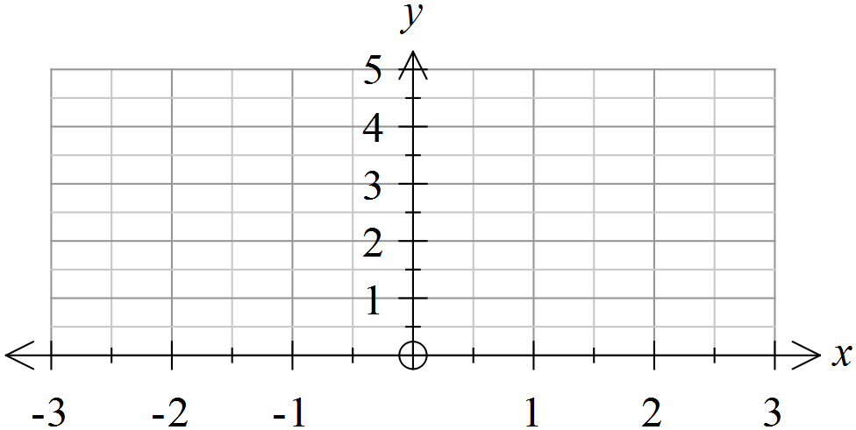

(ii) 



(iii) 



(b) Complete the table below by writing expressions for derived from the values for given in the table. (7)

|  |  |  |  |  |  |
| --- | --- | --- | --- | --- | --- |
| *x* | -2 | -1 | 0 | 2 | 3 |
|  | *m* | *n* | *p* |  |  |
|  |  |  |  |  |  |

(i) Given two expressions for *m* in terms of *a* and *b.*

(ii) State the value of *p*.

(c) The graph of is a transformation of  (4)

(i) Describe this transformation.

(ii) Explain how the relationship between the two expressions accounts for the transformation that occurs.

**Exponential functions**

**In-class investigation**

**Solutions**

**Question 1**

|  |  |  |  |  |  |  |  |  |  |  |  |  |  |  |  |  |  |  |  |  |  |  |  |  |  |  |  |  |  |  |  |  |  |  |  |  |  |  |  |  |  |  |  |
| --- | --- | --- | --- | --- | --- | --- | --- | --- | --- | --- | --- | --- | --- | --- | --- | --- | --- | --- | --- | --- | --- | --- | --- | --- | --- | --- | --- | --- | --- | --- | --- | --- | --- | --- | --- | --- | --- | --- | --- | --- | --- | --- | --- |
| (a) (i)   |  |  |  |  |  |  |  | | --- | --- | --- | --- | --- | --- | --- | | *x* | -2 | -1 | 0 | 1 | 2 | 3 | | *f(x)=2x* | 0.3 | 0.5 | 1 | 2 | 4 | 8 |   (ii)   |  |  |  |  |  |  |  | | --- | --- | --- | --- | --- | --- | --- | | *x* | -2 | -1 | 0 | 1 | 2 | 3 | | *f(x)=3x* | 0.1 | 0.3 | 1 | 3 | 9 | 27 |   (iii)   |  |  |  |  |  |  |  | | --- | --- | --- | --- | --- | --- | --- | | *x* | -2 | -1 | 0 | 1 | 2 | 3 | | *f(x)=4x* | 0.1 | 0.3 | 1 | 4 | 16 | 64 | | |
| Marking key/mathematical behaviours | Marks |
| * Provides accurate values in all cases * Determines values for each of the three functions * Correctly rounds to one decimal place | 1  3  1 |

|  |  |
| --- | --- |
| (b) | |
| Marking key/mathematical behaviours | Marks |
| * Graphs drawn with equivalent y-intercepts * Draws graphs of the correct shapes * Labels each graph * Correctly positions graphs relative to each other * Graphs drawn to approach but not intersect x-axis | 1  1  1  1  1 |

**Question 1 (cont’d)**

|  |  |  |  |
| --- | --- | --- | --- |
|  | Solution | Marking key/mathematical behaviours | Marks |
| (c) | There are no values of *x* for which and if *a* >0 the function cannot be negative | * Identifies range for *f(x)* * Explains limits on function range | 1  1 |
| (d) | (0,1) for all functions | * States the *y*-intercept * Applies *y*-intercept for all functions | 1  1 |
| (e) | *a0=1* | * Provides rule for *x*=0 | 1 |
| (f) | As *a* increases the graph of gets steeper and closer to the *y*-axis while *x*>0.  For  *x* <0 the graph gets closer to the *x* -axis. | * Describes increasing gradient for *x*>0 * Describes decreasing gradient for *x* <0 | 1  1 |
| (g) | (i) 8  (ii) 16  (iii) *g(x)* = 2 *f(x)* | * Determines value for *f(x)* * Determines value for *g(x)* * Relates *g(x)* and *f(x)* | 1  1  1 |
| (h) | *k(x) = h(x+1)* | * Relates *g(x)* and *f(x)* | 1 |

**Question 2**

|  |  |
| --- | --- |
| (a) | |
| Marking key/mathematical behaviours | Marks |
| * Labels graphs with functions * Places graphs in correct relative positions * Identifies correct *y*-intercepts on graphs * Draws graphs through one other correct coordinate where * Shapes graphs correctly | 1  1  1  1  1 |

**Question 2 (cont’d)**

|  |  |  |  |
| --- | --- | --- | --- |
|  | Solution | Marking key/mathematical behaviours | Marks |
| (b) | (i) (0, 1)  (ii) (0, 2)  (iii) (0, 4)  (iv) (0, 8) | * Identifies all intercepts | 2 |
| (c) | (i)  is a horizontal translation of units to the left.  (ii) is a dilation of parallel to the Y axis, scale factor of . | * Identifies a horizontal translation * Identifies  units to the left * Identifies dilation parallel to Y axis * Identifies scale factor | 1  1  1  1 |

**Question 3**

|  |  |  |  |  |  |  |  |  |  |  |  |  |  |  |  |  |  |  |  |  |  |  |  |  |  |  |  |  |  |  |  |  |  |  |  |  |  |  |  |  |  |  |  |  |  |  |  |  |  |  |  |  |  |  |  |  |  |
| --- | --- | --- | --- | --- | --- | --- | --- | --- | --- | --- | --- | --- | --- | --- | --- | --- | --- | --- | --- | --- | --- | --- | --- | --- | --- | --- | --- | --- | --- | --- | --- | --- | --- | --- | --- | --- | --- | --- | --- | --- | --- | --- | --- | --- | --- | --- | --- | --- | --- | --- | --- | --- | --- | --- | --- | --- | --- |
| (a)  (i)   |  |  |  |  |  |  |  | | --- | --- | --- | --- | --- | --- | --- | | *x* | -2 | -1 | 0 | 1 | 2 | 3 | | *f(x)=5x* |  |  | 1 | 5 | 25 | 125 |   (ii)   |  |  |  |  |  |  |  | | --- | --- | --- | --- | --- | --- | --- | | *x* | -2 | -1 | 0 | 1 | 2 | 3 | | *f(x)=10x* |  |  | 1 | 10 | 100 | 1000 |   (iii)   |  |  |  |  |  |  |  | | --- | --- | --- | --- | --- | --- | --- | | *x* | -2 | -1 | 0 | 1 | 2 | 3 | | *f(x)=5-x* | 25 | 5 | 1 | $$\frac{1}{5}$$ | $$\frac{1}{25}$$ | $$\frac{1}{125}$$ |   (iv)   |  |  |  |  |  |  |  | | --- | --- | --- | --- | --- | --- | --- | | *x* | -2 | -1 | 0 | 1 | 2 | 3 | | *f(x)=10-x* | 100 | 10 | 1 | $$\frac{1}{10}$$ | $$\frac{1}{100}$$ | $$\frac{1}{1000}$$ | | |
| Marking key/mathematical behaviours | Marks |
| * Correctly enters integer values to tables * Correctly enters fractional values to tables | 2  2 |

**Question 3 (cont’d)**

|  |  |  |  |
| --- | --- | --- | --- |
|  | Solution | Marking key/mathematical behaviours | Marks |
| (b) | The tables are symmetrical in that *f(x)=10x* equals *f(x)=10-x* when the *x* value is multiplied by -1. | * Identifies equal values * Links equivalence to changing *x* values | 1  1 |
| (c) |  | * Identifies relevant rule | 1 |
| (d) | Applies for all *n* | * Generalises rule * Identifies values of *n* for which the rule applies | 1  1 |
| (e) | $$\frac{1}{216}$$ | * Applies identified rule | 1 |

**Question 4**

|  |  |
| --- | --- |
| (a)  (i)  (ii)  (iii) | |
| Marking key/mathematical behaviours | Marks |
| * Correctly indicates *y*-intercepts on the graphs * Correctly indicates *x*-axis as an asymptote * Draws each pair of graphs symmetrically * Labels graphs throughout * Draws graphs with the correct shape * Positions graphs correctly with at least one point other than the *y*-intercept in correct position | 1  1  1  1  1  4 |

**Question 4 (cont’d)**

|  |  |  |  |  |  |  |  |  |  |  |  |  |  |  |  |  |  |  |  |
| --- | --- | --- | --- | --- | --- | --- | --- | --- | --- | --- | --- | --- | --- | --- | --- | --- | --- | --- | --- |
| (b)   |  |  |  |  |  |  | | --- | --- | --- | --- | --- | --- | | *x* | -2 | -1 | 0 | 2 | 3 | |  | *m* | *n* | *p* |  |  | |  |  |  |  |  |  |   (i)  (ii) *p=1* | |
| Marking key/mathematical behaviours | Marks |
| * Completes the table for *x* = -2, -1 and 0 * Completes the table for *x* = 2 and 3 * Provides two accurate expressions for *m* * Identifies *p* as 1 | 2  2  2  1 |

|  |  |  |  |
| --- | --- | --- | --- |
|  | Solution | Marking key/mathematical behaviours | Marks |
| (c) | (i) Reflection over the *y*-axis  (ii) Since  i.e.  for opposite values of *x*, the functions have the same value. The opposite values of *x* position the points equidistant from the origin and the equal values of *y* position the points equidistant from the *x* -axis. Hence the symmetry. | * Identifies the reflection * Identifies the line of reflection * Explains the symmetry | 1  1  2 |